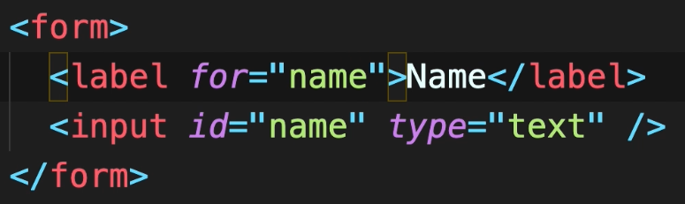

If we use the id of the target input field in the for attribute of label, they become connected. In this case when we click the Name for example, the input field will get focused.

**Buttons:** if we use submit as button type, it will submit the form. If we use reset, it will clear out the form.

